Gander Minor Hockey Association
Coaching Certification Guide

Please follow the steps below to gain the required coaching certification. A complete list of coaching requirements per division can be found here:
www.hockeynl.ca/clinics/certification-required.

A list of previously completed courses can be found on the Hockey Canada HCR 3.0 Spordle website. https://myaccount.spordle.com/login. If you do not have an HCR 3.0 (Spordle) account, you will be required to create one before registering for coaching clinics.

*Criminal record checks are valid for a period of 3 years while there is currently no expiry on the majority of Hockey Canada courses.

Criminal Record Check/Vulnerable Sector Check -
Go to the GMHA website, under FORMS – “Letter for Police Record Check & Vulnerable Screening”. Print this form and bring it to the Court House to receive a court check. Take the court check to the RCMP for a Vulnerable Sector Check. The letter you print off informs the Court and RCMP that you are a GMHA volunteer and therefore no fee is required. Return completed checks to your divisional director.
www.ganderminorhockey.ca/forms

HNL Screening -
Go to the GMHA website, under FORMS – “HockeyNL Screening Application”. Print this form, fill in the required information and return to your divisional director.
www.ganderminorhockey.ca/forms

Respect in Sport for Activity Leaders -
This is an online course that is required for all coaches and volunteers.
https://hnl.respectgroupinc.com

GMHA COACHING CERTIFICATION GUIDE

HU Online Coach 1/Coach 2 -
This is a hockey Canada online self paced course.
*This course is a prerequisite for Coach 1 and Coach 2.
https://register.hockeycanada.ca/clinics

Coach 1 -
Required for all coaches in U7 & U9. Can take place in person or via Zoom. Dates are limited.
https://register.hockeycanada.ca/clinics

Coach 2 -
Required for all coaches in U11 and above. Can take place in person or via Zoom. Dates are limited.
*Coach 1 is not a prerequisite for Coach 2.
https://register.hockeycanada.ca/clinics

NCCP Development 1 (D1) -
Required for Head Coach of U13 and higher.
https://register.hockeycanada.ca/clinics

HU Online Safety -
This is the Safety/Trainer Course – a Hockey Canada Online self paced course. Each team is required to have at least one coach certified.
https://register.hockeycanada.ca/clinics

Goaltending 1 -
This course is required for any goaltender coaches.
https://register.hockeycanada.ca/clinics

GMHA COACHING CERTIFICATION GUIDE

HU Online Checking -
This is a Hockey Canada online self paced course.
Required in divisions with checking.
https://register.hockeycanada.ca/clinics

* When registering for Hockey Canada Clinics, be sure that the drop-down bar near the top of the page indicates Hockey Newfoundland and Labrador. This ensures that you are looking at clinics for the correct province. Once HNL is selected, select the appropriate course below.
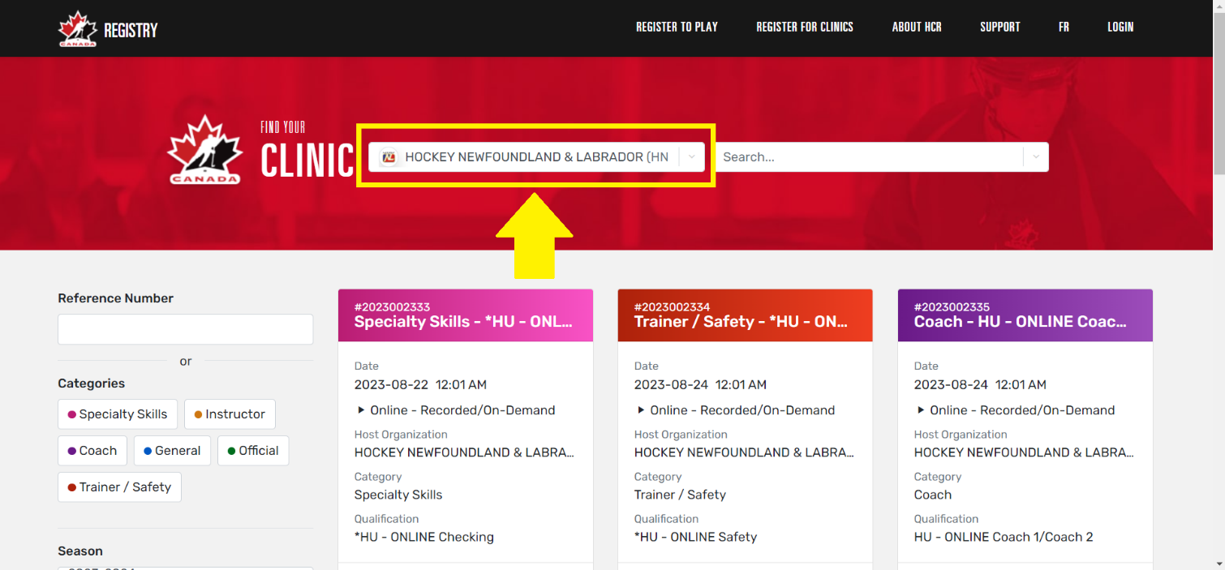

Please reach out to your director or any member of the GMHA executive if you have any questions.

